Takeda x IOCO – Pareto Chart/ Combo Chart Visualization – DAD-1345
Pareto Chart/Combo Chart
A Pareto Chart is a type of chart that combines other charts such as line chart and bar chart.
A Combo Chart combines two or more data types into one graphic.
Quick Access:
- Black Panther’s Figma
- Takeda’s Existing Figma -
- Storybook Links (for informational purposes to repurpose as much as possible or copy with pride)
  - Old version of Combo Chart in Storybook - https://www.figma.com/design/5BFYOgkh14TTqgXnNIeB7d/Design-Library_Insight-Center?node-id=6862-16355&t=yXaOuRnbKputwQYz-0
    - Can most likely be deleted (please do so after this is assessed)
  - Current version of Pareto Chart - Molecules / Charts / Pareto Chart - Basic ⋅ Storybook
    - Would be nice to consolidate so a toggle can take you from one to the other

- High level Requirements Summary
To create, using the High Charts map library software, Pareto Chart/Combo Chart as a visualization object using the Existing common component in our storybook as a base for future development.
This visual should be added as a common configurable component within the Dashboarding Framework, as a new type of visual that can be added by any business users within a simplified UI. Name should be “Pareto Chart/Combo Chart,”.
We already have an existing common component; it isn’t complete nor is it configurable through the UI. The goal is to reuse and build the remaining elements/requirements into/onto it as approved by Victor Bianchi. There is no need to create a new one. Should make use of all configurations from Bar/Column Chart and Line Chart.

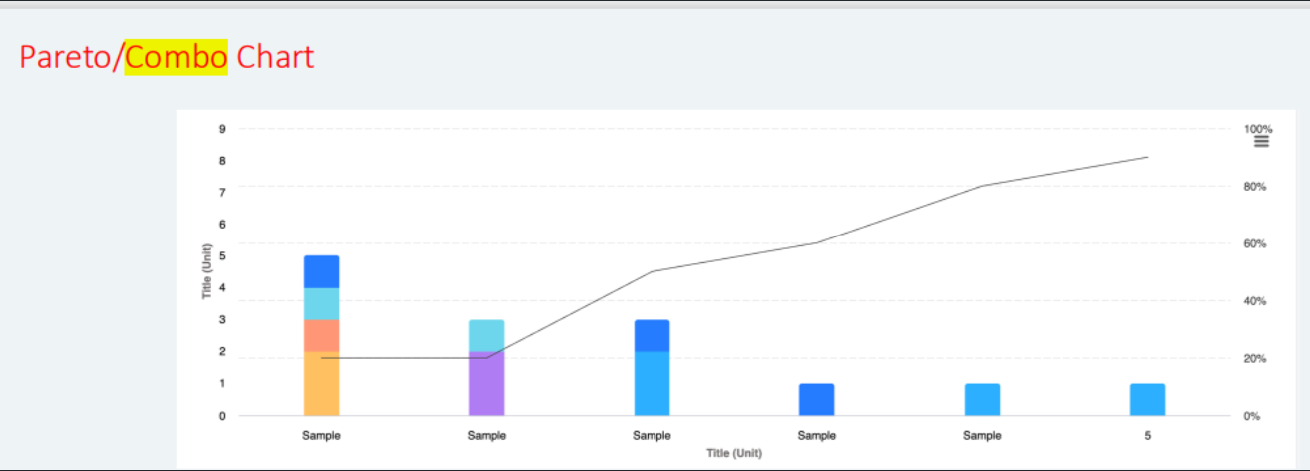
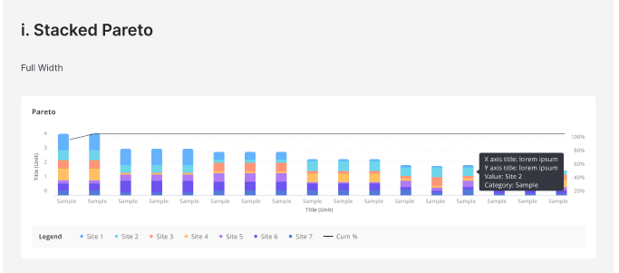
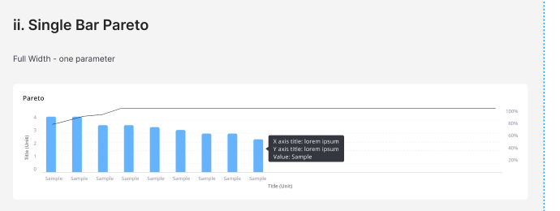
- Detailed Requirements
Configuration Screen – CCC’s:
https://onetakeda.atlassian.net/browse/BICN-86029
- Req#0 - Config Screen
- Req#1 - Bar Chart tile name
- Req#2 - Tile’s size
- Req#3 - X-Axis Data Field
- Req#4 - Y-Axis Data Field
New Development:
- Req#5 - Linear grouping (sequencing of data in numerical or an ordered sequence which can result in something increasing or decreasing) OR Categorical grouping (categorical grouping of data on distinct categories, example: product types / departments/ countries/gender)

- Req#6 - Select colour palette. (Allow flexibility for incoming new color selection wheel/MFE)

- Req#7 - Configure auto-scaling (automatically adjustment of the scale)

- Req#8 - Provide option to select secondary field to further differentiate segments.
  - This requirement is about adding a second level of data categorization allowing the user to see distinct segments of each Pareto/Combo Chart for which we currently have 2 stacking options available to use

- Req#9 - Allow user to specify aggregation function (sum, average, count, etc.)

- Req#10 - Offer download, filter, sort, search AS elements in periphery of the charts that should be pulled/reused from the existing storybook components.
  - The show/hide of actual values - this should be part of the configuration popup OR can be added as a toggle in the marker by filter/within another existing element in the periphery of the Pareto/Combo Chart.

- Req#11 - Tooltips and drilldowns
  - User should have the ability to configure the tooltips with other values, other parameters, links, images, etc.
  - Drill down would be an action that happens when the user clicks as an example then it might open another page or open a flyout. As a default whenever a chart is selected, it should “pop” to the user and be easily identifiable.

- Req#12 - Vertical (toggle up and down or show/hide or on/off) + Horizontal (this is a switch between two different states) these will be dropdowns. Should be initially configured as part of the configuration screen.

